*Heaven’s Light is Our Guide*

# Rajshahi University of Engineering & Technology

# Department of Electrical & Computer Engineering

**Lab Report**Experiment No: 01  
Name of the experiment: Study the relationship between phase voltage & line voltage of a wye (Y) connected three-phase balanced system.

|  |  |
| --- | --- |
| Course Code | 1202 |
| Course Title | Circuit & System – II Sessional |

|  |  |
| --- | --- |
| **Submitted By:** | **Submitted To:** |
| Name             : Sharmin Akter  Roll                : 2210055  Registration : 1109  Session           : 2022-23 | Oishi Jyoti,  Lecturer.  Electrical & Computer Engineering, RUET. |

**INDEX**

1. Experiment No
2. Experiment Name
3. Objectives
4. Required Apparatus
5. Theory
6. Circuit Diagram
7. Procedure
8. Data Table
9. Result
10. Discussion

**Experiment No:** 01

**Name of the Experiment:** Study the relationship between phase voltage & line voltage of a wye (Y) connected three-phase balanced system.

**Objectives:**

* To learn how to make wye (Y) connections
* To study the relationship between voltage & current in three-phase system

**Required Apparatus:**

* Voltmeter
* AC Voltage source
* Ammeter
* Connecting wires
* Rheostats

**Theory:** In a wye (Y) connected three-phase system, the line and phase quantities are related by,

$V_{p}=V_{L}/\sqrt{3}$

$I_{p}=I_{L}$

Where $V_{p}$ is phase voltage, $V_{L}$ line voltage. $I_{L}$& $I_{p}$ are line current & phase current respectively.

**Circuit Diagram:**

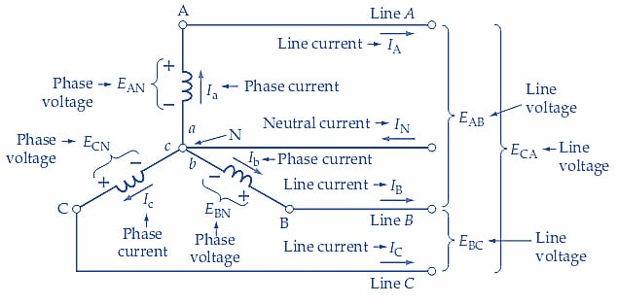

**Procedure:**

* A circuit was created following the circuit diagram using the components required.
* Voltmeter and ammeter were connected in the places marked in the diagram.
* Readings of the meters were recorded in a data table and error was calculated.

**Calculations:**

Wye Connection, Ip = $I_{L}$; finding errors for $V_{L}$& ${ V}_{p}$

For 1,

Vp(c) = 74.6/√3 = 43.07

Error = (44-43.07)/44

= 2.114%

For 2,

Vp(c) = 92.8/√3 = 53.59

Error = (54-53.59)/54

= 0.76%

For 3,

vp(c) = 39.60/√3 = 22.85

Error = (23.34-22.85)/23.34

= 2.1%

**Data Table:**

|  |  |  |  |  |  |  |
| --- | --- | --- | --- | --- | --- | --- |
| SI | $V_{L}$ | Vp(m) | Vp(c) | $I_{L}$ | Ip | Error |
| 1 | 74.6 | 44 | 43.07 | 0.37 | 0.37 | **2.114%** |
| 2 | 92.8 | 54 | 53.59 | 0.49 | 0.49 | **0.76%** |
| 3 | 39.60 | 23.34 | 22.85 | 0.23 | 0.23 | **2.1%** |

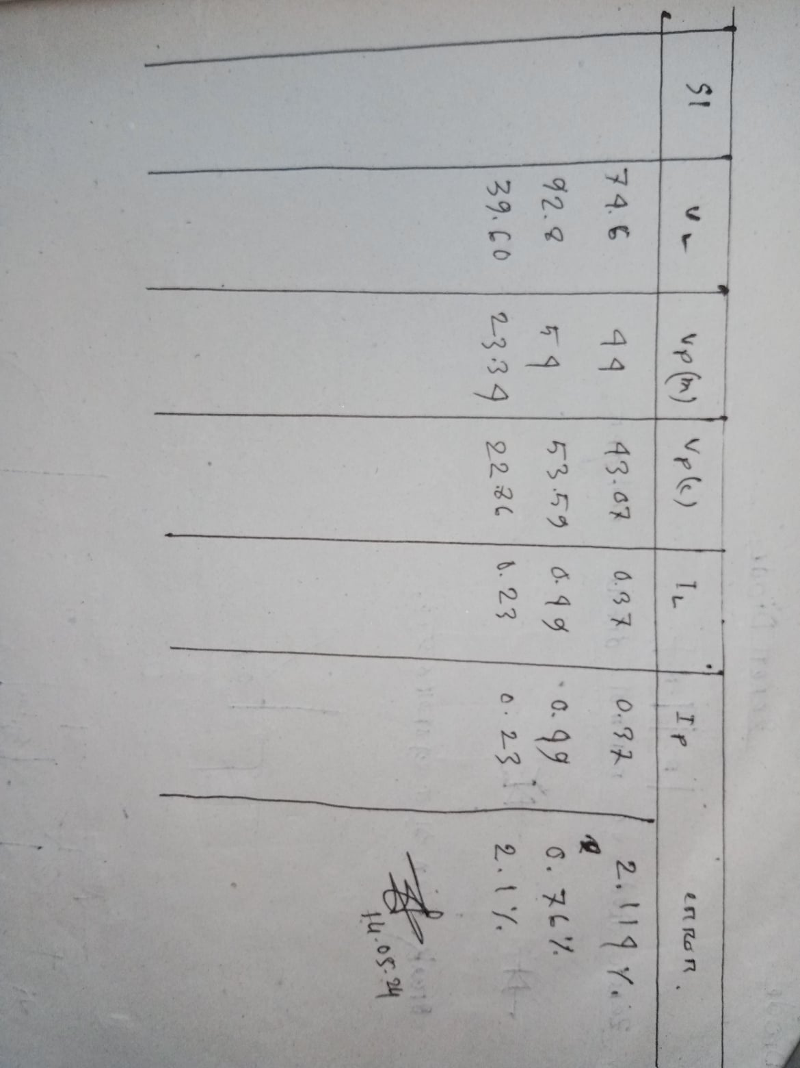

**Result:**

As it can be seen from the error calculation, the result is almost as expected. Even if it’s not equal to the calculated value, it’s approximately close to it. So it can be said that, $V_{p}=V_{L}/\sqrt{3}$

$I_{p}=I_{L}$

**Discussion:**

Ignoring the small margin of error, which may have caused due to external or internal factors or system loss, the experiment was a success.